Azure Function App

Lab Steps

Task 1: Login to Azure Portal

1. If you have logged into any other Azure Account from previous labs or your own account, please logout of it.

Task 2: Create a Azure Function App

1. On the Azure portal menu or from the Home page, select **Create a resource**.  
   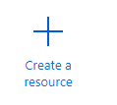

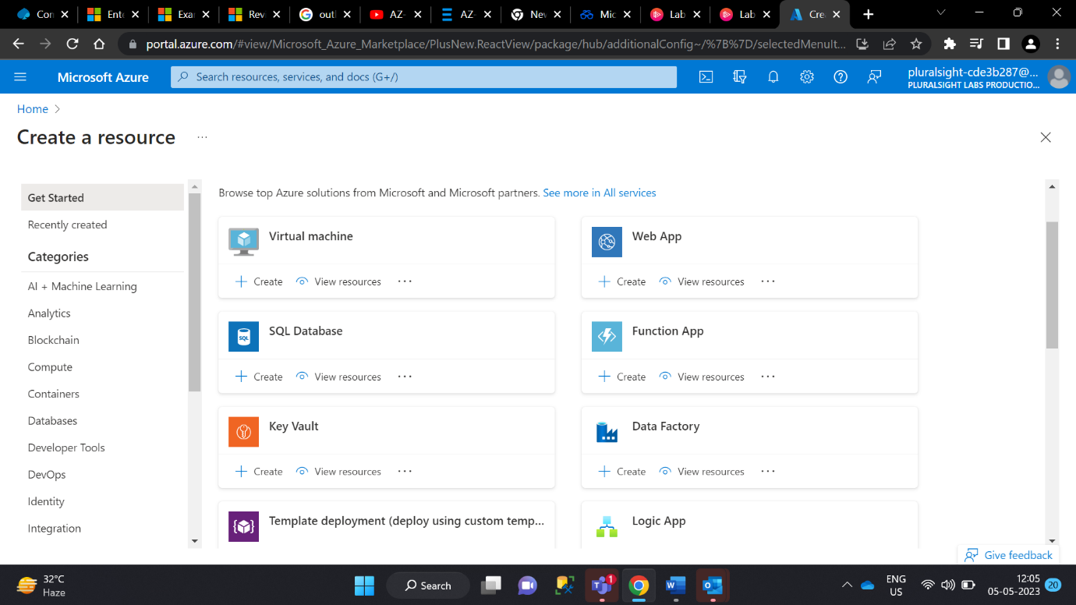

4.Fill the below info

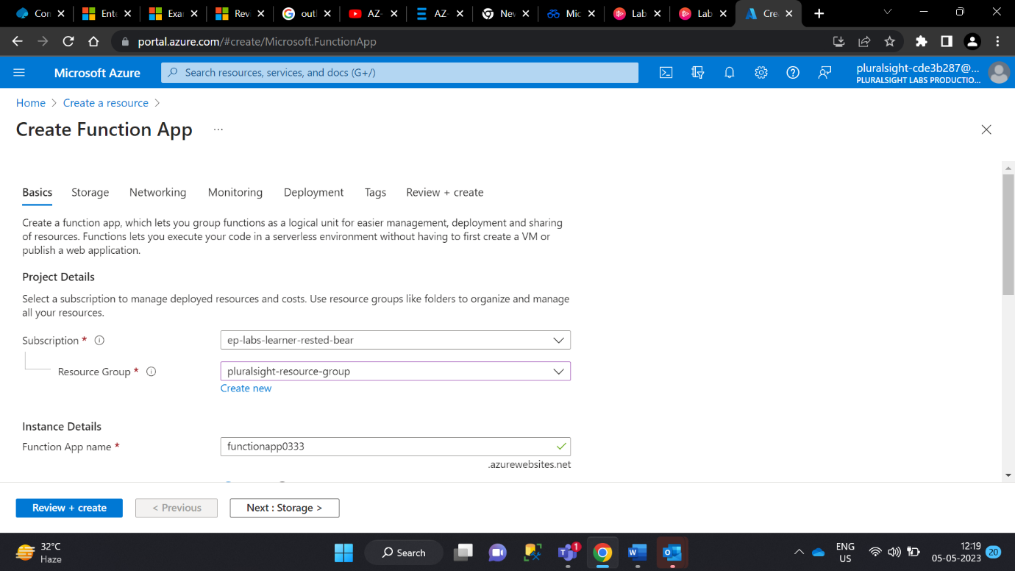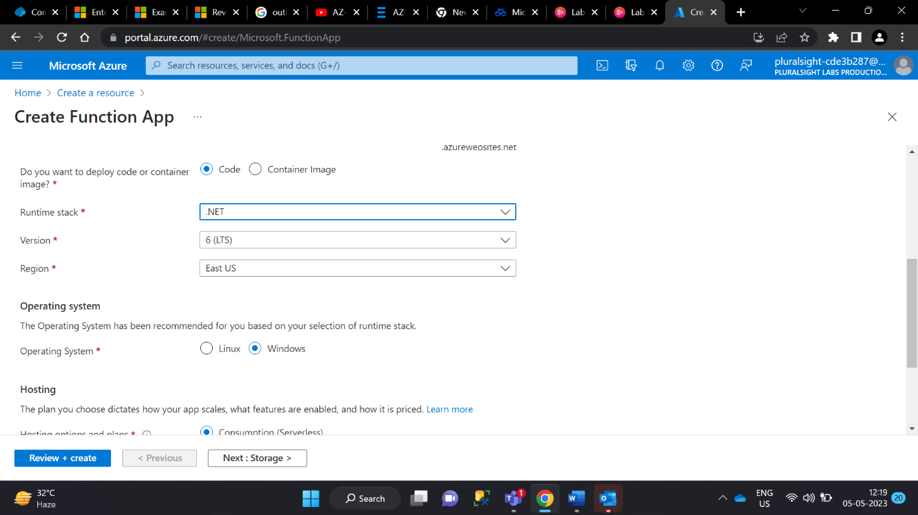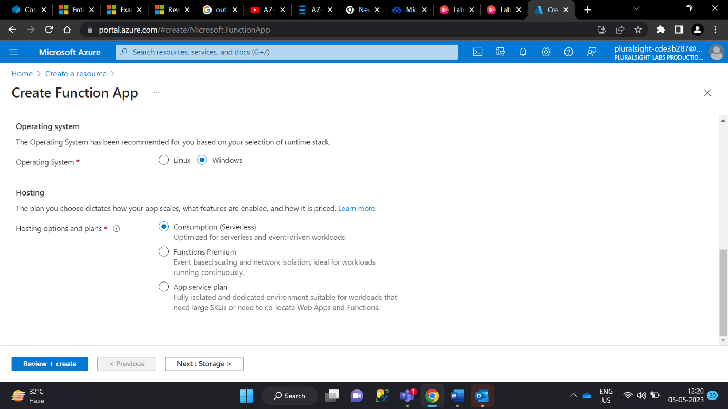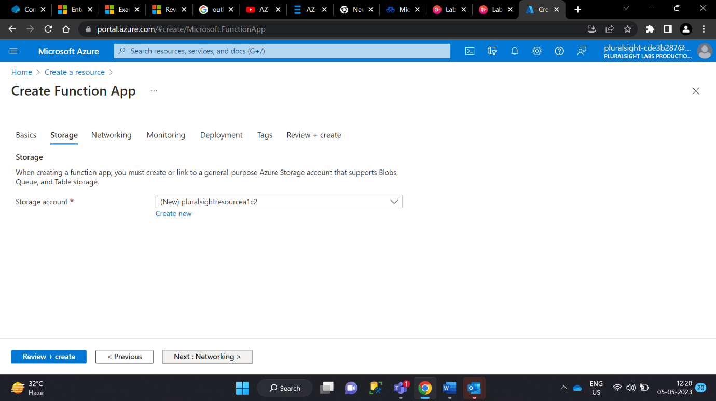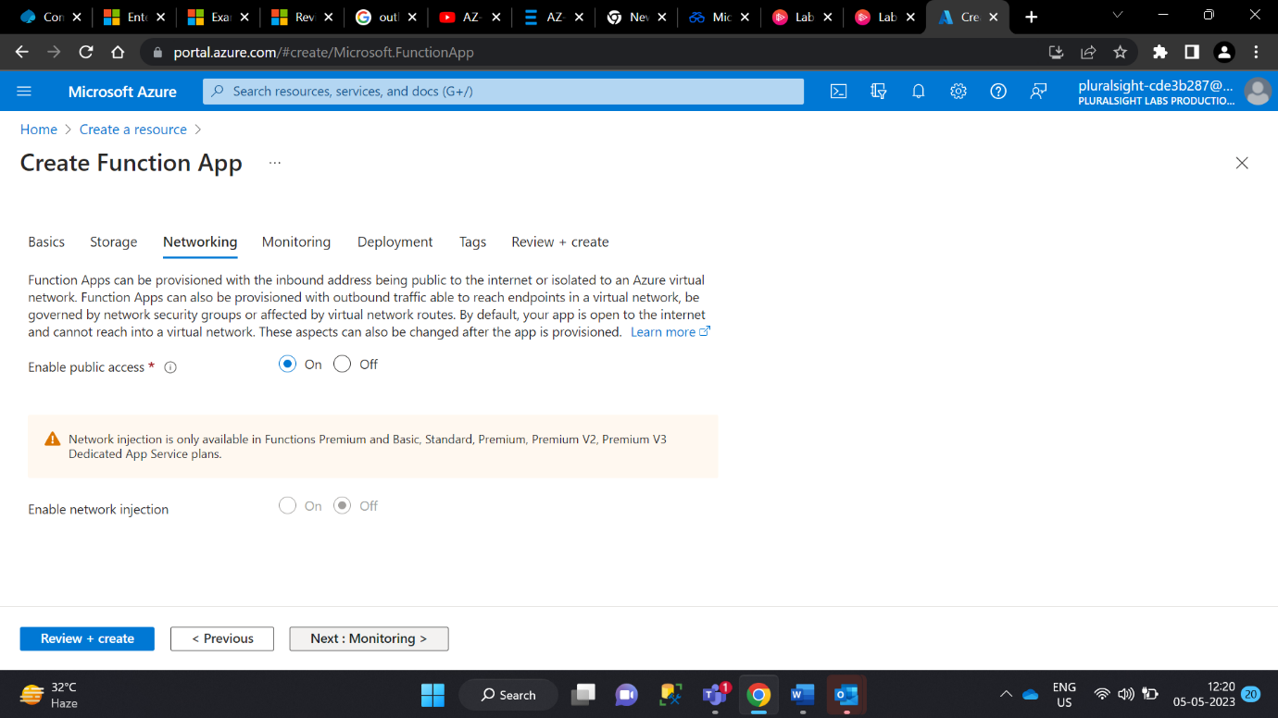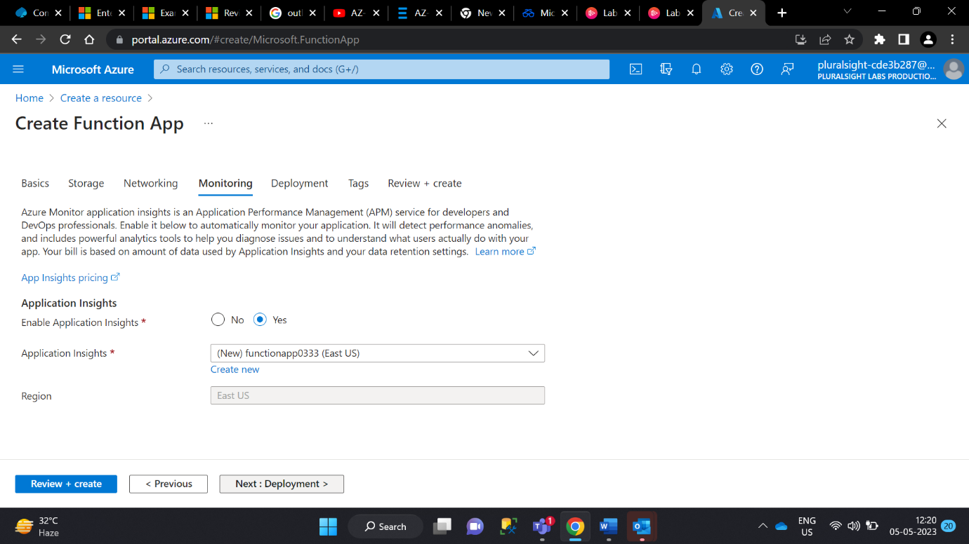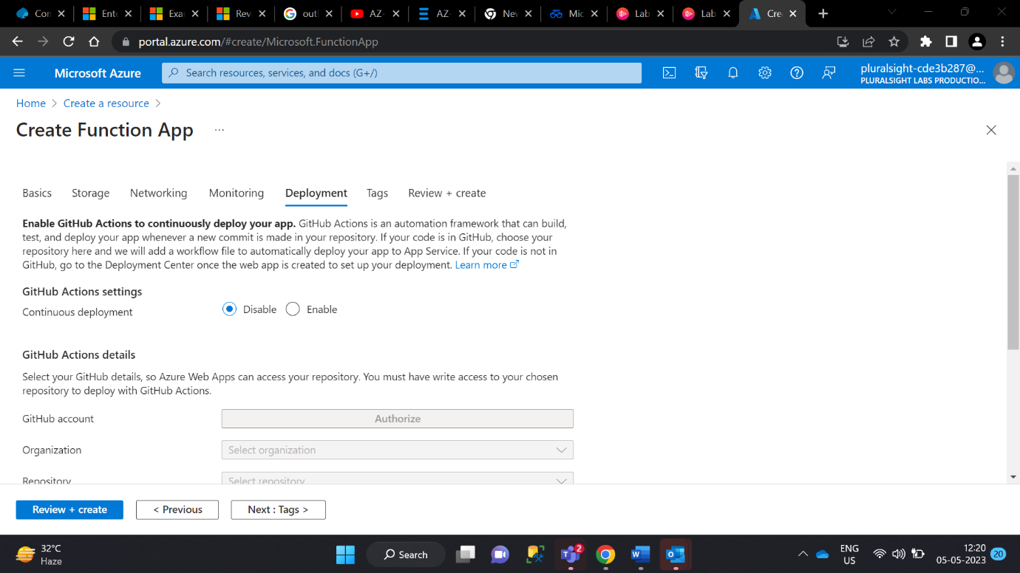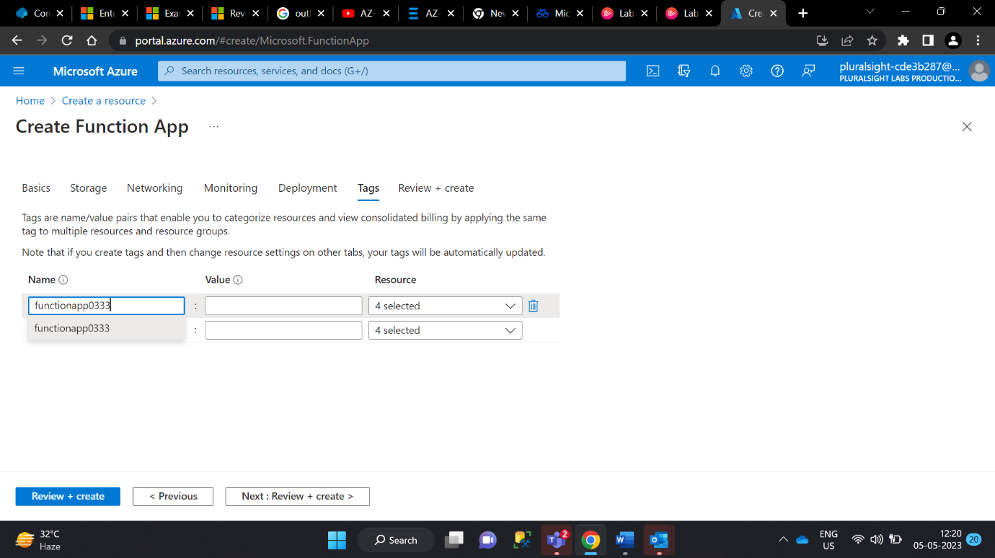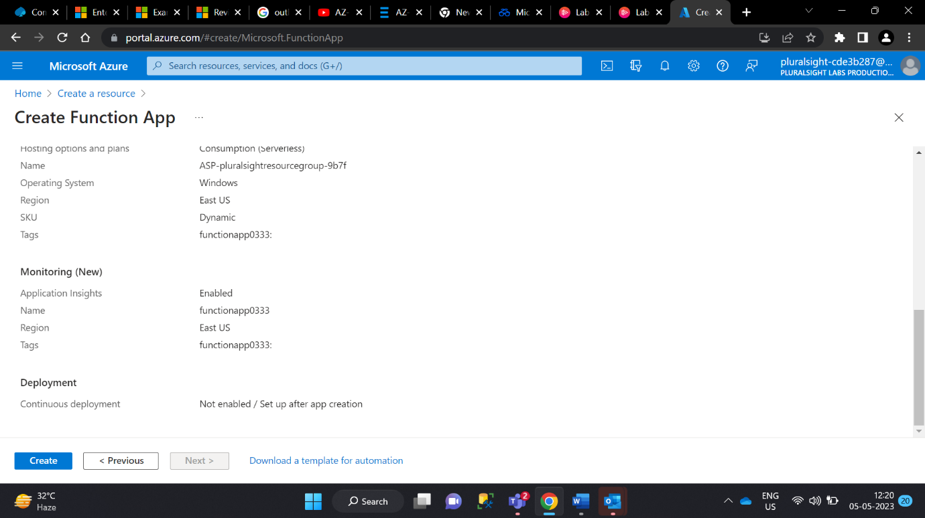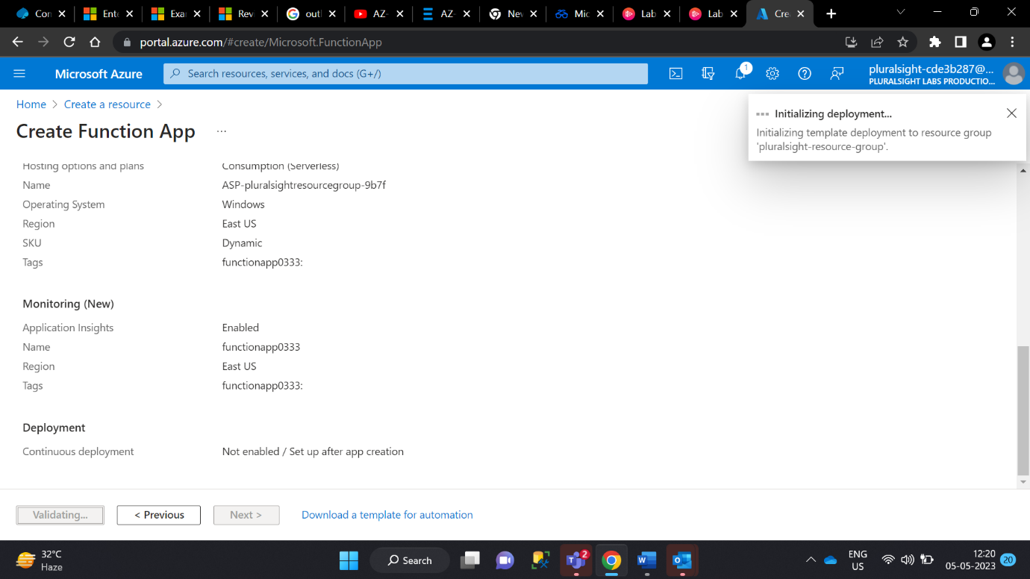

1. After that wait for few minute to deploy the app

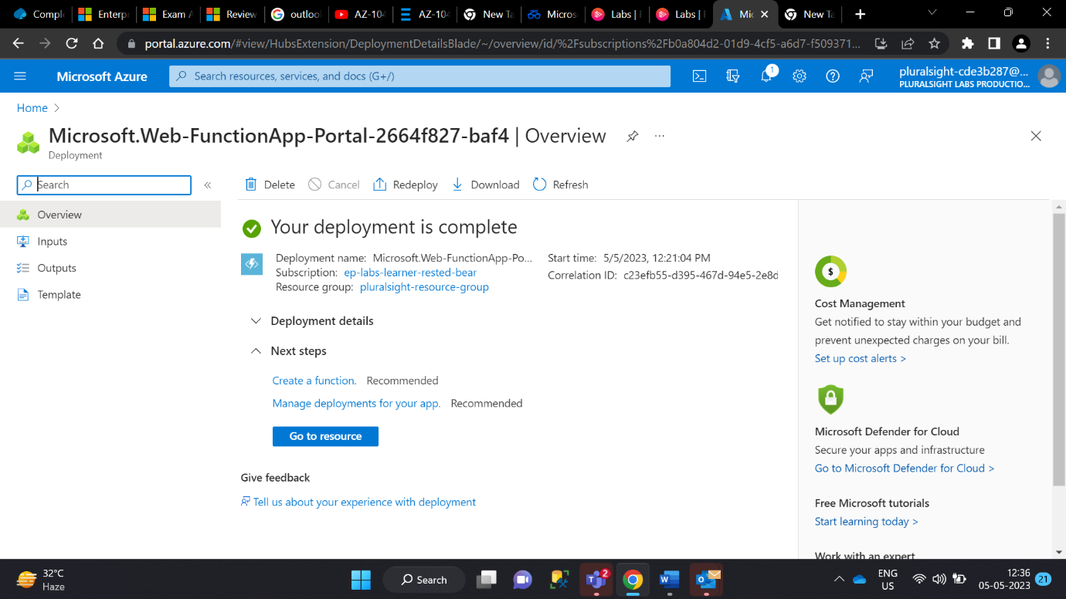

1. Go to resource

1. From the left menu, select **Functions**.
2. Click the **+ Create** button at the top.

1. From the **Select a template** section, filter for and select **HTTP trigger: C#**.

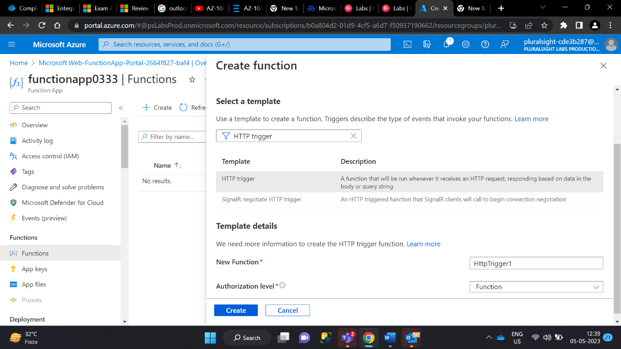

1. Click the **Create** button and wait for the deploy to complete.
2. Select **Code + Test** on the left.

1. You should see the .NET C# source code displayed. From the top, select **Test/Run.**

Make sure the HTTP method is set to POST.

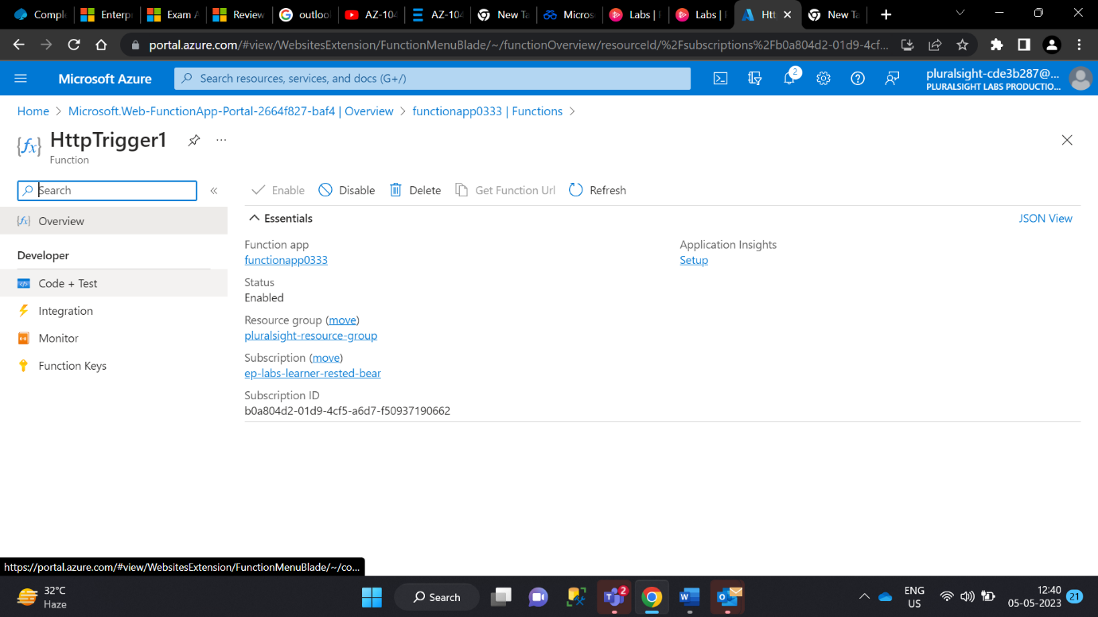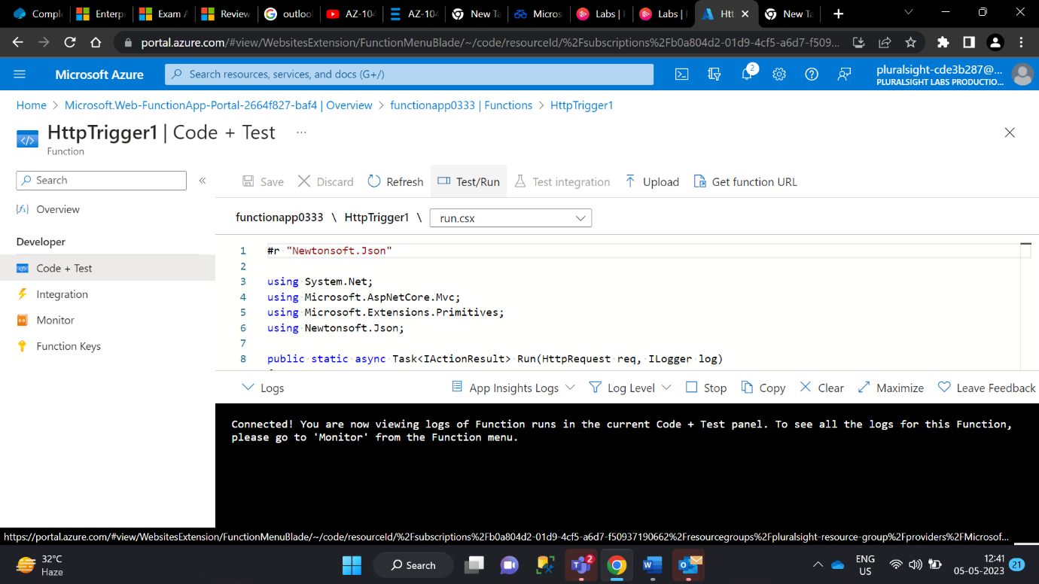

1. In the **Body** section, set the nameparameter to match your name.
2. The rest of the configuration should stay as it is. Click the **Run** button.

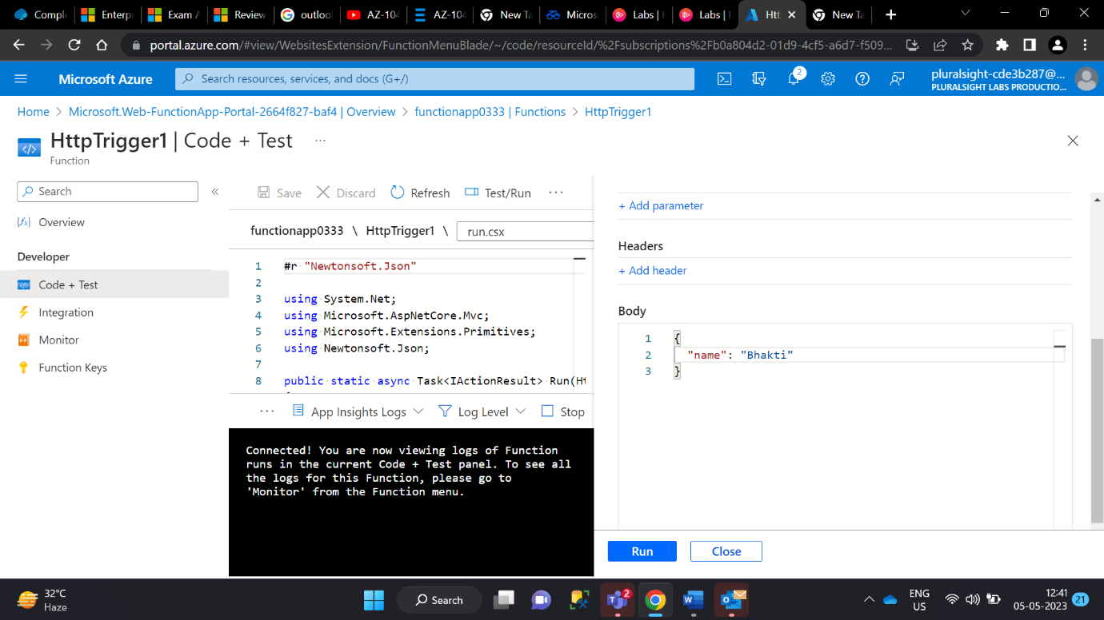

After a few seconds there should be a **Logs** window displayed with the logs from the function app. As well, the tab in the pane on the right should automatically switch from **Input** to **Output,** and the **HTTP response code** will display a status code of **200 OK** and response content of **Hello <your name>** will be listed below.

1. Click **Run**.

You should see a greeting displayed similar to before.

Congratulations! You have created your first HTTP triggered Azure Function App!